|  |
| --- |
| **Computer Network** |
| NC.Hafiz Abdul Manan |
| BESE 16(B) |
| To: DEMO Kabir Ahmad |
|  |
| **.** |
| **10/5/2012** |
|  |

**Comparison between Switch and Hub time for Packets transmission**

|  |  |  |
| --- | --- | --- |
| **Number of Packets** | **Average Time for HUB** | **Avrg Time for Switch** |
| **10** | **5ms** | **7ms** |
| **15** | **6ms** | **8ms** |
| **20** | **5ms** | **8ms** |
| **25** | **6ms** | **7ms** |
| **30** | **6ms** | **7ms** |

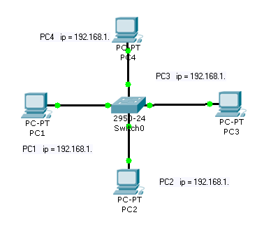 **For Hub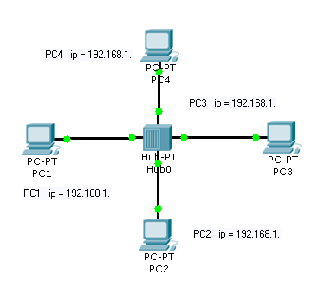: For Switch:**

**Code:**

time_of_hub=[6 5 6 6 5];

time_of_switch=[8 8 8 7 7];

packet=10:5:30;

plot(packet,time_of_hub)

hold on

plot(packet,time_of_switch,'r')

xlabel('Packet');

ylabel('Time taken');

grid;

**Graph:**

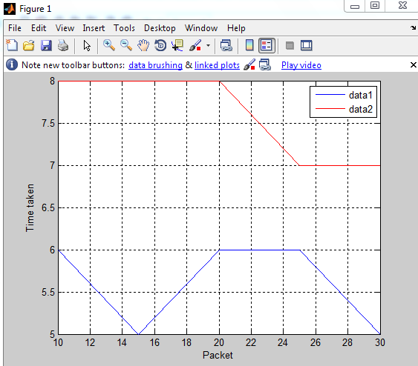

**Data1 shows the average time for switch.**

**Data2 shows the average time for Hub.**